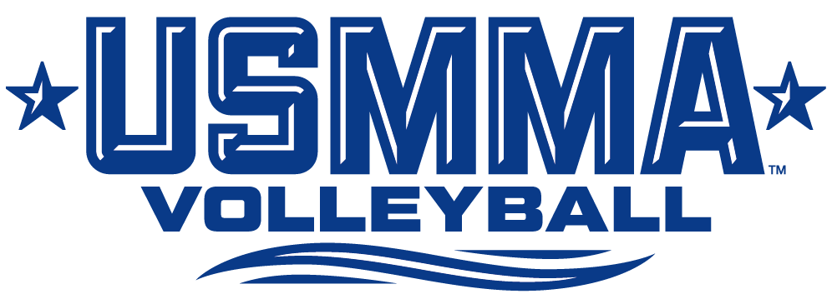

**2025 Roster**

**# Name Yr. Pos. Ht. Hometown/High School**

2 Meredith Elwood Jr. S/DS 5-4 Waupaca, Wis./Waupaca Christian Academy

3 Stephanie Schatzman Sr. L 5-5 Virginia Beach, Va./Floyd E. Kellam

4 Sierra Richardson Jr. DS 5-9 Valparaiso, Ind./Washington Township

5 Alexa Tipps Jr. S/RS/DS 5-4 Palmdale, Calif./Paraclete

7 Sofia Dohr Fr. MH/Pin 6-0 Austerlitz, N.Y./Academy of the Holy Names

8 Sydney Douglas So. Pin/L 5-9 Herndon, Va./Virginia Academy

9 Emma Borlie Fr. L/DS/S 5-4 Baltimore, Md./Rosedale Christian Academy

10 Adriana C. Rodríguez Fernández Fr. Pin/L/DS/S 5-7 San Juan, P.R./The San Juan Math, Science and Tech Center

11 Carly Soboloski Fr. Pin 6-0 Peoria, Ariz./Sunrise Mountain

13 Brooklyn Branum Fr. Pin/DS 5-6 Coppell, Texas/Coppell

15 Jenny Dyke So. MH/Pin 5-11 Grand Rapids, Mich./Kenowa Hills

17 Erin Stillinger Jr. MH/Pin 6-0 Keller, Texas/Keller

19 Maddie Mayer So. MH/Pin 6-0 Centennial, Colo./Grandview

**Coaching Staff**

**Head Coach:** Tony Nocera (Eastern Connecticut State ’06) – Third Season

**Assistant Coaches:** Kyleigh Kappas, LT Commander Jonathan Jones

**Student Assistant:** Jackson Tolle

**Athletic Trainer:** Dan Braut, ATC (Lyndon State, ’97) - 12th Season

**Pronunciations** (by syllable; emphasis on the **BOLD CAPS**)

#11 – So-buh-**LAH**-ski

#15 – **DIKE** (rhymes with bike)

#19 – **MAY**-er

HC – No-**SAIR**-uh

SAC - **TOLL**